Programming Precepts BCPR109

Algorithms

Introduction

Computer programs
To communicate with a computer, we have to tell it what to do, step by step. This is done using a computer program. In order to write a computer program, we must first analyse the task and there are a number of techniques to help with this.

Algorithm
An algorithm is a set of step by step instructions for solving a problem. It is written using ordinary English.

Structure Diagram
Structure diagrams are a pictorial way of representing the logic of an algorithm.

Pseudocode
Pseudocode is a method of expressing the logic of an algorithm using statements.

What is an algorithm?
Algorithms normally start with an input and end with an output.

Example 1
Algorithm for catching a bus
1 Go to the bus-stop
2 Wait for the bus
3 When the bus arrives, get in the bus
4 Pay for your trip
5 Sit in an empty seat

Write algorithms for the following situations

Example 2
Organize a friend to pick you up from the airport.

Example 3
Pay for a shirt at the checkout of a department store.

Give shirt to checkout operator
Checkout operator scans tag
Checkout operator reads out price
if cash:
Get required cash from wallet
Give cash to checkout operator
Checkout operator deposit cash in register
elif card:
Get card from wallet
Swipe card
Select account
Enter PIN
Checkout operator removes tag from shirt
Checkout operator gives you shirt back

Example 4
Given the ex-GST price of an item, calculate its GST inclusive price.

Summary
Algorithms can be thought of as:
- a series of mechanical, repetitive, routine processes

- a complete set of unambiguous instructions needed to perform a task or solve a problem

- a clear description of how a computer is to proceed in an organised way through a sequence of elementary steps (a computer program)

Characteristics of an algorithm
- unambiguous
- precise
- finite
- effective

What algorithms are used in computer systems?
In any computer system, many algorithms are used. For example, some of the algorithms used by an ATM (Automatic Teller Machine) are:
Checking that the correct pin number has been entered
Performing a withdrawal of cash
Performing an account balance enquiry

Exercise
Describe at least one algorithm that would be used by each of the following computer systems.

EFTPOS terminal

traffic lights

supermarket checkout

speech recognition system
In the following table, look at each system and write down at least one algorithm that would be needed.

Computing System | Algorithm

Accounting
Asset Register
ATM
Betting Systems
Budgeting/forecasting
CAD/CAM
Census
Container tracking
Courier delivery systems
Document flow
EEG analysis
EFT-POS
Engineering
Forestry - yields etc
GPS
GST
Job costing
Library
Lift control
Music - computer generated
Networks
Number plates
Operations research
Process control
Project management
Sample Analysis
Scheduling (nurses, doctors, pilots, students.. )
Share market
Simulation
Sorting of Kiwifruit
Speech recognition
Traffic control
Weather
Work flow

Structure Diagrams
Structure diagrams are used to represent the logic of an algorithm. The first step is to break the algorithm down into a beginning, a middle and an end.
Name of algorithm
Beginning
Middle
End

Order
A structure diagram must be read in the correct order: first the name of the algorithm at the top and then the beginning, middle and end are read across from left to right.

Symbols
In this course, the following symbols will be used.

Process, summary or name

Input or output

Loop or iteration

If statement or condition

Algorithms

Algorithms have three parts

Beginning initialize variables and totals, get inputs

Middle main part, usually has loops and/or conditions (IF), processes, outputs

End may have outputs, summary statements

Example 5
Convert $NZ to $A
Get amount in $NZ
Multiply amount by exchange rate
Output amount in $A
Beginning
Middle
End

Get exchange rate

Example 6
Condition (if-then-else) is used when a test yields two possibilities, eg T/ F or Y/N.
Drinking Age Test
Output Result
Input age
Age >=18

Result = Pass
Result = Fail
T
F

Example 7
Iteration (do-while, do until, while) is used to repeat actions while a certain condition is true.

What is wrong with this structure diagram?
How could you fix it?

List of numbers 1 to 100
output
“End of list”
while number <101
number = 1
Add 1 to number

output number

number = 1

Exercises

Next week you will use some algorithms to convert numbers to different bases. You can then try writing structure diagrams for these algorithms.

1 Redraw these boxes into a structure diagram, using the correct shaped box for each.

Add numbers between 4 and 20 (inclusive)
Add number to total
While number < 21
Middle
End

Display total
total = 0

Beginning
Add 1 to number

Number = 4

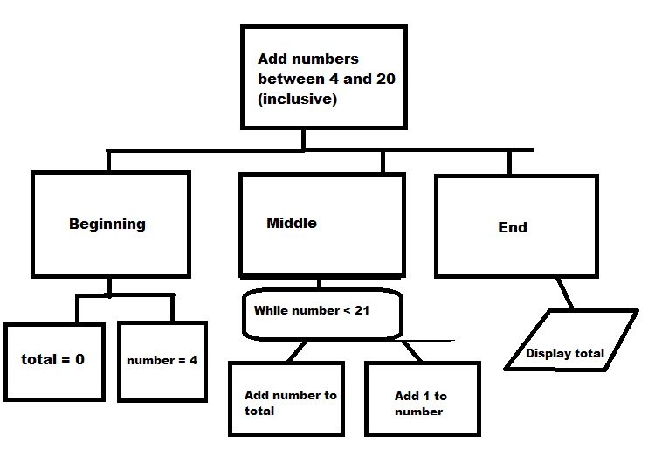

2 This structure diagram is incorrect. (a) What is wrong with it?
(b) Redraw it correctly.
Process one supermarket customer
until no more items in trolley
display total
set total to 0
add price to total
scan item
Display description and price

3 Arrange the following boxes to form a structure diagram. Draw the correct shaped boxes.

Is hours worked > 40?
ordinaryPay = 0
Calculate ordinaryPay
Calculation of pay

overtimePay = 0
Display
totalPay
Calculate overtimePay
totalPay=ordinaryPay + overtimePay
totalPay = 0
Beginning
Middle
End
Input hours worked

Beginning

4 Arrange the following boxes to form a structure diagram. Draw the correct shaped boxes.
Calculate discount
Output discount
Get next order
Calculate discount for a list of orders

Look up discount rate for the customer that the order is for
Beginning
Do until no more orders
Middle
End

Get first order

5 Arrange the following components as a structure diagram which describes an algorithm for playing one hole in a round of golf.
Play one hole
Begin
Middle
End
Select club
Set Score to 0
Put ball on tee
Until ball in hole
Hit ball
Add 1 to score
Walk to ball
Write score on card
Go to tee

6 Arrange the following into a structure diagram for displaying a list of numbers from 1 to 10. Use the correct shaped boxes.
beginning
display numbers from 1 to 10
until count = 10
count = 1
end
add 1 to count
middle
display count
display “End of list”

7 Rearrange these to form a structure diagram for paying for an item by EFTPOS. Draw the correct shaped boxes.

Swipe card
Display message
message = “Declined”

Verify pin number

Pay for an item by EFTPOS
message = “Accepted”
Enter pin number
End

Middle
Beginning
Is there enough money in the account?

Set message = “ ”

8 Rearrange the following to form a structure diagram for printing letters to debtors (the customers who owe the company money). After all the letters have been printed the total amount owing is printed. Draw the correct shaped boxes. (3 marks)
Middle
Print debtors letters and total amount owing
totalOwed = 0
Get details of first customer
amountOwing > 0
Print letter
Add amountOwing to totalOwed
Get details of next customer
Print totalOwed
Until no more customers
Begin
amountOwing = 0
End

9 Draw a structure diagram for the following algorithms.
(a) List even numbers from 2 to 20.
(b) List the 5 times table from 5 times 1 to 5 times 12.
(c) Count up to 100 in steps of 10 and display each number.
(d) Add 5 numbers together and display their sum.
(e) Determine whether a student gets an A, B or C grade if 50 is needed for a C, 60 is needed for a B and 75 is needed for an A.
(f) An ATM machine
(g) EFTPOS transaction
(h) Card swipe entry
(i) Sorting 3 numbers
(j) Sorting lots of numbers

10 Textbook page 23, 1-24, 1-22, 1-20

Pseudocode
The following example of pseudocode is for an algorithm to add the first n positive integers. You are not required to write pseudocode in this course.

Begin
1 sum  0
2 i  1
3 input n
4 WHILE 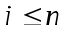 DO
a sum  sum + i
b i  i + 1
5 output sum
End

Answers

Ex 1 Redraw these boxes into a structure diagram, using the correct shaped box for each.
Add numbers between 4 and 20 (inclusive)

End
Beginning
Middle

While number < 21

Display total

total = 0

Number = 4

While <
Add number to total
Add 1 to number

Ex 2

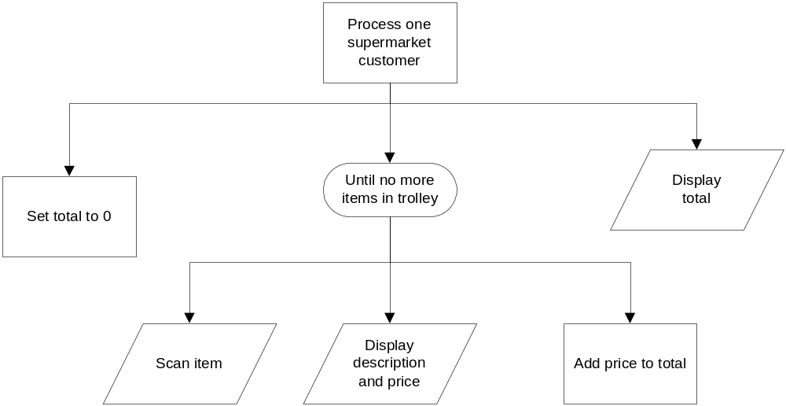

Ex 3

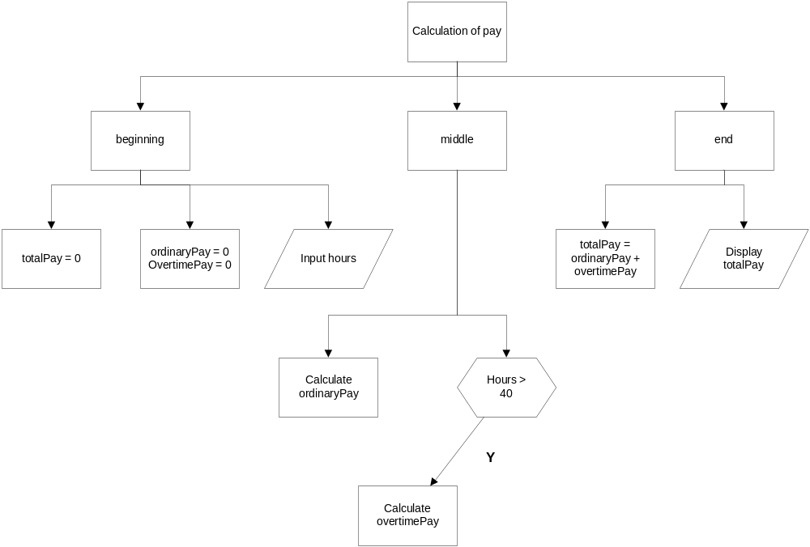

Ex 4

Calculate discount for a list of orders
Middle
End
Beginning

Do until no more orders

Get first order

Output discount

Get next order

Look up discount rate for the customer that the order is for

Calculate discount

Ex 5

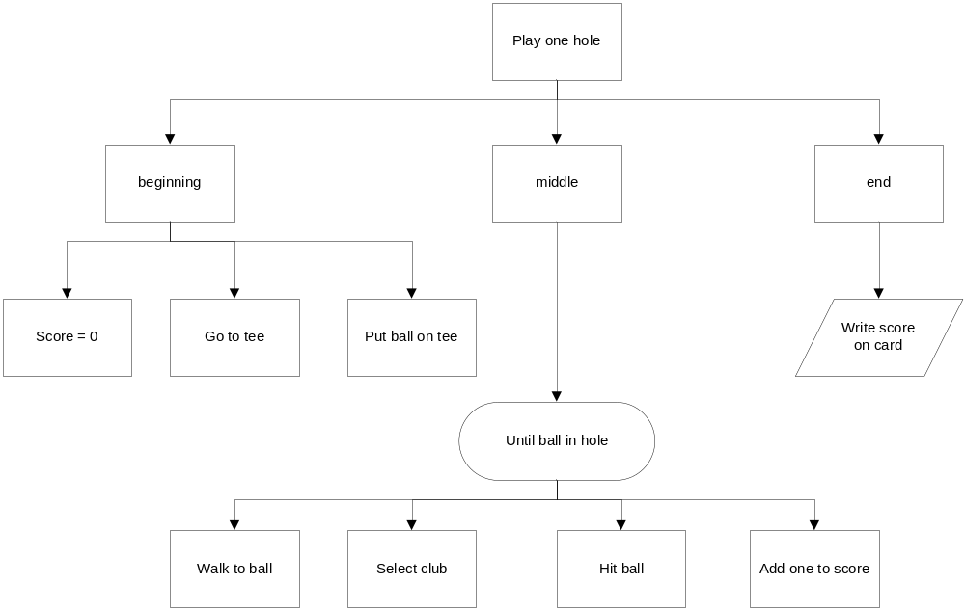

Ex 6
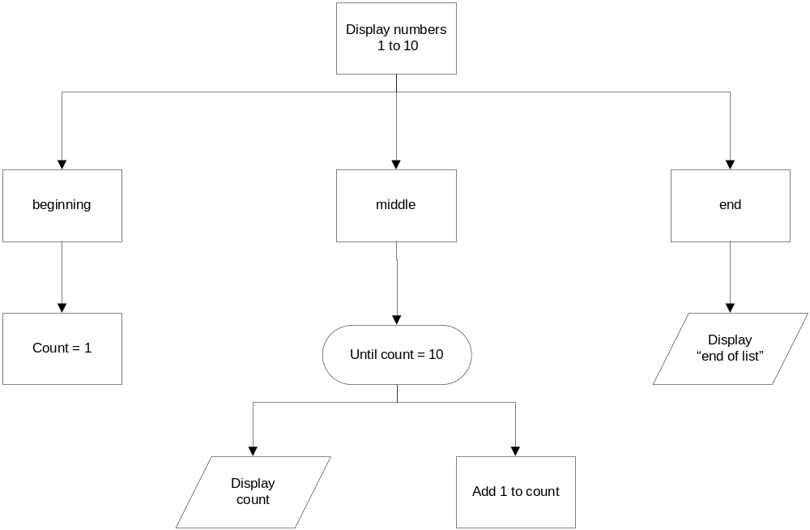

Ex 7
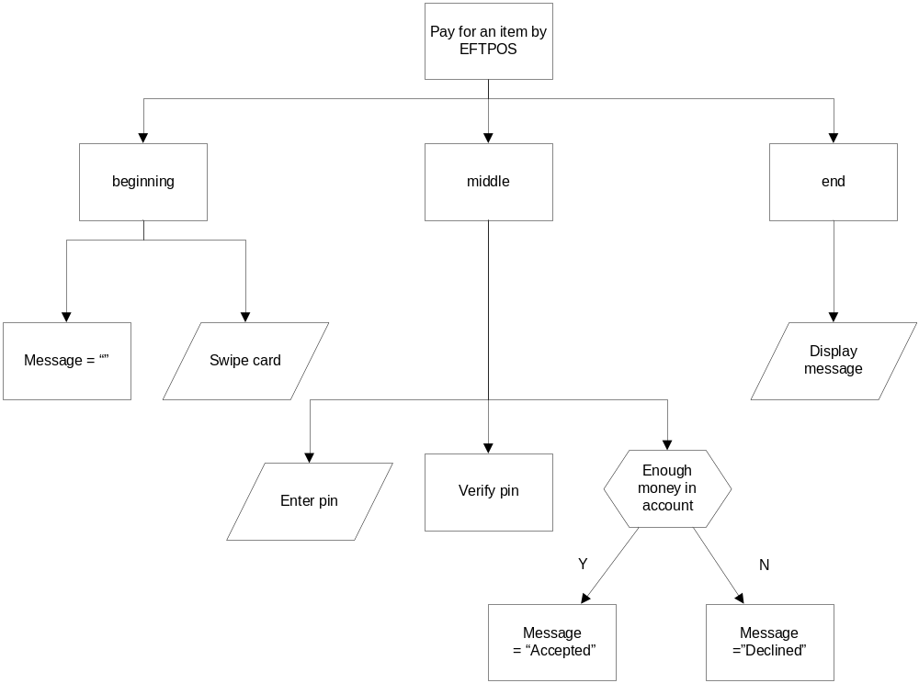

Ex 8
